Entrees

(Served with choice of steamed rice or fried rice)

Gourmet Delights

|  |  |  |  |
| --- | --- | --- | --- |
| Combination Lo Mein | $13.25 | Singapore Chow Fun | $13.25 |

Combination Lo Mein Singapore Chow Fun $13.25

Happy Family $13.25 Kung Pao Delight $13.25

Sesame Prawn or Beef $14.50

Pork

Moo Shu Pork (with 4 pancakes) $12.25 Pork Lo Mein $11.75

Sweet & Sour Pork $11.75 Pork with Mixed Vegetable $11.75

Chicken

General Tso's Chicken $11.75 Lemon Chicken $12.50

Moo Shu Chicken (with 4 pancakes) $12.25 Chicken/Cashew Nuts $11.75

Sweet & Sour Chicken $11.75 Curry Chicken $11.75

Chicken with Snow Pea $12.25 Chicken Lo Mein (soft noodle) $11.75

Chicken with Broccoli $12.25 Chicken/Mixed Vegetables $11.75

Kung Pao Chicken $12.25 Almond Fried Chicken $11.75

Chicken with Garlic Sauce $12.25 Mandarin Chicken $11.75

Orange Chicken $13.25 Honey Walnut Chicken $13.95

Beef

Moo Shu Beef (with 4 pancakes) $12.95 Beef Lo Mein (soft noodle) $12.25

Beef with Broccoli $12.25 Beef with Mixed Vegetable $12.25

Beef with Cashew Nuts $12.25 Kung Pao Beef $12.25

Mongolian Beef $12.95 Teriyaki Beef (or chicken) $12.75

Pepper Steak $12.25 Beef with Tomato (soft noodle) $12.75

Schezuan Beef $12.25 Beef with Black Bean Sauce $12.75

Seafood

Honey Walnut Prawns $14.95 Prawn with Garlic Sauce $13.50

Moo Shu Prawn $13.95 Curry Prawn $13.50

Sweet & Sour Prawns $13.50 Shrimp Lo Mein $13.50

Prawn with Cashew Nuts $13.50 Prawn /Mixed Vegetables $13.50

Kung Pao Prawn $13.50 Prawn with Broccoli $13.50

Shrimp with Lobster Sauce $13.50 Princess Prawn $13.50

Prawn with Snow Peas $13.50 Shrimp Chow Fun $13.50

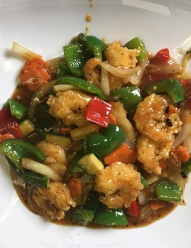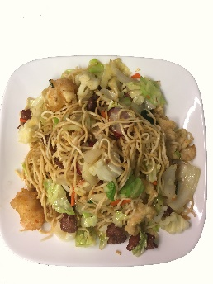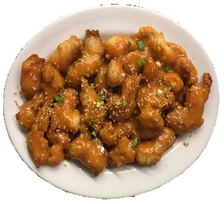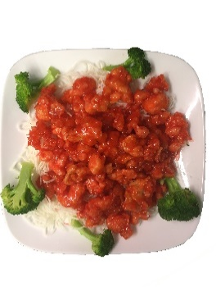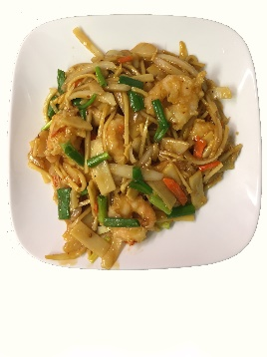

Orange Chicken

Shrimp with Black Bean Sauce

Shrimp in Garlic Sauce

Combination

Lo Mein

Almond Fried Chicken

$13.25